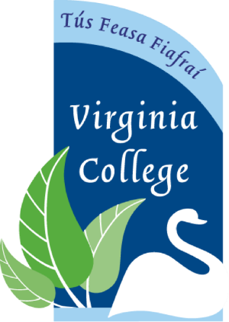

Virginia College Parents’ Association Meeting
Date: 13th MAY
Time: 7.30 pm.
Agenda
- Minutes from the last 2 meetings
- Uniform Swap and School Jacket fitting
- School concert
- School newsletter
- Feedback on Policy on Diversity (MD)
- AOB

